**Wheeless Road Elementary School**

***Parental Involvement Policy and Plan for Shared Student Success***

***2022-2023 School Year***

***Mr. Timothy Jones, Principal***

***2530 Wheeless Rd.***

***Augusta, Ga. 30906***

***(706) 796-4985***

*Wheeless.rcboe.org*

***Revised July 27, 2022***

**What is Title I?**

Wheeless Road Elementary is identified as a Title I school as part of the Elementary and Secondary Education Act of 1965 (ESEA). Title I is designed to support State and local school reform efforts tied to challenging state academic standards in reinforce and enhance efforts to improve teaching and learning for students. Title I programs must be based on effective means of improving student

achievement and include strategies to support

parental involvement. All

Title I schools must

jointly develop with

all parents a

written parental

involvement

policy.

School Plan for Shared

Student Achievement

**What is it?**

This is a plan that describes how Wheeless Road Elementary will provide

opportunities to improve parent engagement to support student learning.

Wheeless Road Elementary values the contributions and involvement of

parents to establish an equal partnership for the common goal of improving

student achievement. This plan describes the different ways that Wheeless

Road Elementary will support parent engagement and how parents can help

plan and participate in activities and events to promote student learning at school

and at home.

**How is it revised?**

Wheeless Road Elementary School invited all parents to attend an input/revision meeting to review and revise this parental involvement policy, as well as the school-wide plan, our school-parent compact and the parental involvement budget. Additionally, parent input and comments regarding this plan are welcome during the school year through an online form. The plan is posted on our school Web site for parents to view and submit feedback throughout the year. All parent feedback received during the year will be used to revise the plan for the next school year. We also distribute an annual survey to ask parents for their suggestions on the plan and the use of funds for parental involvement. Parents can also give feedback during several parent meetings and activities during the school year.

**Who is it for?**

All students participating in the Title I, Part A program, and their families, are encouraged and invited to fully participate in the opportunities described in this plan. Wheeless Road Elementary will provide full opportunity for the participation of parents with limited English, parents with disabilities and parents of migratory children.

**Where is it available?**

At the beginning of the year, the plan is shared with parents via the input/revision meeting and the Annual meeting. The plan will also be posted on the school Web site. Parents can also retrieve a copy of the plan in the Parent Resource Center.

School-Parent Compacts

As part of this plan, Wheeless Road Elementary and our families will develop a school-parent compact, which is an agreement that parents, teachers, and students will develop that explains how parents and teachers will work together to make sure all our students reach grade-level standards. The compacts will be reviewed and updated annually based on

feedback from parents, students

and teachers during the

parent involvement events

and the School Forum.

The school-parent

compacts are kept

with each child’s

teacher if parents

need a copy.

2022–2023 District Goals

During the 2022-23 school year, we will utilize technology and the Richmond County School System Instructional Framework to increase academic achievement across all tested content areas by 3%.

During the 2022-23 school year, through our Induction Support Program, we will increase the percentage of highly effective teachers and leaders retained in the Richmond County School System by 3%.

During the 2022-23 school year, we will increase the graduation rate from 73.77% to 75% by a continued focus on the strategy map and working to produce graduates that meet the Richmond County School System Profile of a Graduate.

2022–2023 School Goals

**Goal # 1:** By the end of FY23, the percentage of students scoring at or above grade level on vocabulary as measured by I-Ready assessment will increase from 13% to 18%.

**Goal # 2:** By the end of the FY23, the percentage of students at or above grade level on numbers and operations as measured by I-Ready assessments will increase from 5% to 10%.

**Goal # 3:** Create a positive school culture that results in the school’s climate star rating increases by 2 stars by the end of the 2022-2023 school year.

**Let’s Get Together!**

Annual Title1 Meeting-TBA

We invite you to a virtual meeting, learning and sharing about out Title1 program including our parent and family engagement policy, the school wide plan, the school parent compact and parent requirements. Invites will come by flyers, DOJO, Shout Outs, or School Sign.

Parent Night- TBA

Come join us for a night of information to support our parents in supporting our students.

Parent-Teacher and Student Conferences – TBA

Scheduled updates on your child’s progress.

Volunteer Training – TBA

Become a volunteer. We need you.

*Volunteer Training –TBA*

Educational Sessions – TBA

Gain knowledge about topics relevant to your child’s education.

Notice will be given for all other upcoming events

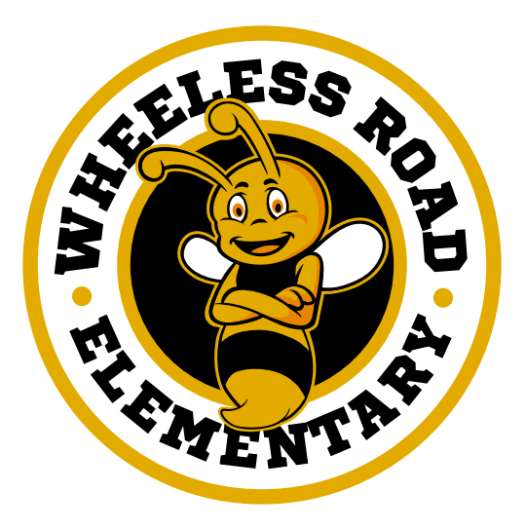

Wheeless Road Elementary is committed to

helping our parents participate in the parental activities listed in this plan. Please call or email

us if you have any questions/concerns or issues

regarding attending meetings.

(706) 796-4985 or Email  
beeksvi@boe.richmond.k12.ga.us

**Parent Resource Center**

Come visit the Parent Resource Center to check out books, study materials, and activities to use at home with your child. Computers are available for parents to explore the Parent Portal and educational resources.

Days and Times: TBA

Parental Involvement

Wheeless Road Elementary believes that parental involvement means the participation of parents in regular two-way, and meaningful communication involving student academic learning and other school activities, including ensuring:

* That parents play an integral role in assisting their child’s learning.
* That parents are encouraged to be actively involved in their child’s education at school.
* That parents are full partners in their child’s education and are included, as appropriate, in decision-making and on advisory committees to assist in the education of their child.
* The carrying out of other activities as described in this plan.

**Wheeless Road Elementary is Branching Out!**

Wheeless Road Elementary will take the following measures to promote and support parents as an important foundation of the school in order to strengthen the school and reach our school goals. We will:

* Ensure that all information related to school and parent programs, meetings, and other activities is published in both English and Spanish, posted on the school Web site, and included in the monthly school newsletter for all parents.
* Provide parents information in a timely manner about Title I and the rights of parents to be involved. Provide written notice to all parents in regards to the identification WRES is a Title 1 School Improvement school. Use SHOUT Point messaging system, flyers and post events on the Website to invite all parents to meetings and encourage them to attend.
* Share information in English and Spanish on the school Website and in the school newsletter for parents to understand the school’s academic standards and assessments as well as the ways parents can monitor their child’s progress and work with educators.
* Communicate with all families and the community on a regular basis regarding school-wide events and activities, through phone messages, school website DOJO and flyers.
* Work with our parents to develop relevant trainings and helpful presentations to educate our staff on the importance of parental involvement.
* Provide necessary materials and handouts for parents at conferences, meetings, and activities to help parents work with their child to improve their child’s achievement.
* Collect feedback from parents at all events in order to respond to parents’ requests for additional support for parental involvement activities.



**Share Your Thoughts**

We want to hear from you. If you have any suggestions or if there is any part of this plan that you feel is not satisfactory with the students’ and the school’s goals for academic achievement, please provide us with your comments in the space provided and leave this form in the Main Office:

Name: (optional)



Telephone Number: (optional)



